ASSIGNEMENT 1
Postman test cases:
Get all categories: GET http://127.0.0.1:5000/api/categories
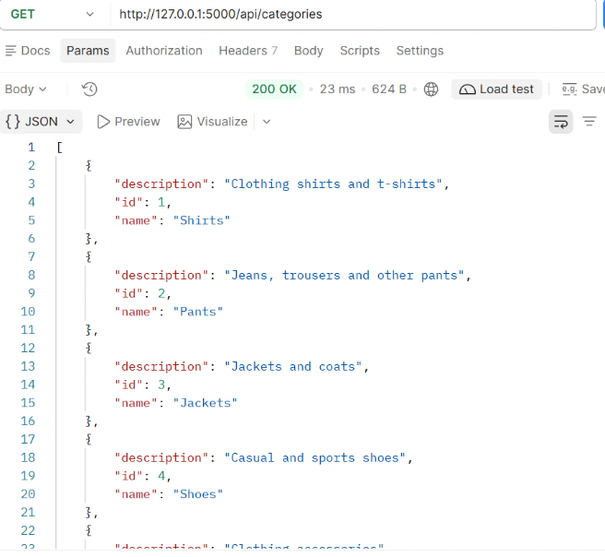
Get all brands: GET http://127.0.0.1:5000/api/brands
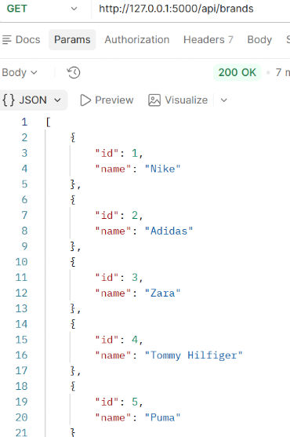
Get all genders: GET http://127.0.0.1:5000/genders
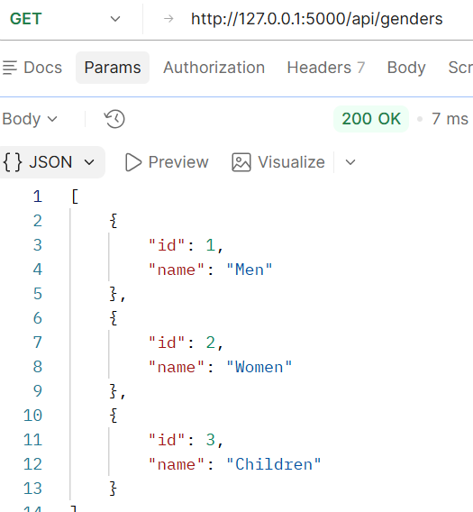
Get all sizes: GET http://127.0.0.1:5000/api/sizes
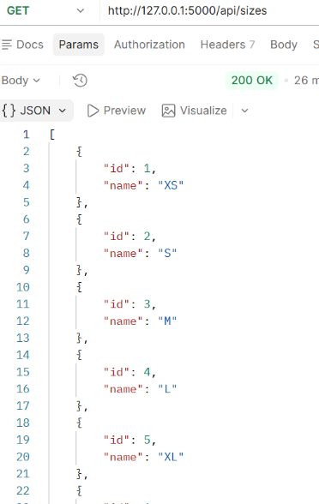
Get all colors: GET http://127.0.0.1:5000/api/colors
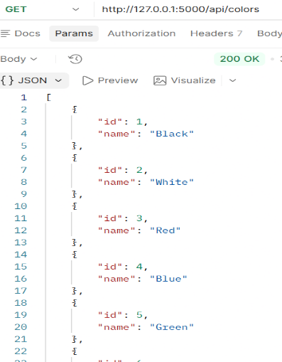
Get all products: GET http://127.0.0.1:5000/api/products
Is empty since in the DB I haven’t put any product yet.
Login as administrator: POST http://127.0.0.1:5000/auth/login
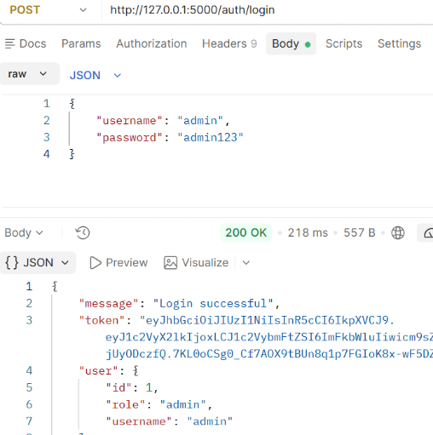
Create category with POST, we copy the token that was created when we logged in as administrator and paste it in the Authorization tab:
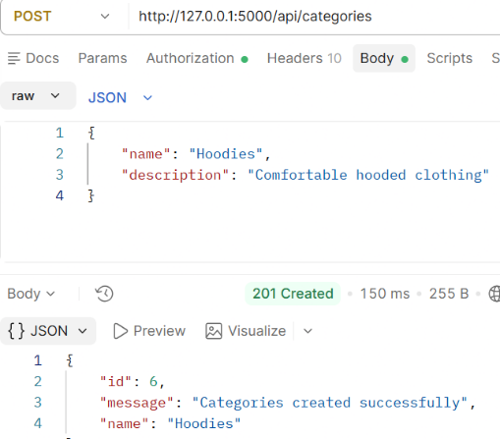
Create a product now with POST http://127.0.0.1:5000/api/products, we paste the admin token in Authorization tab and we get:
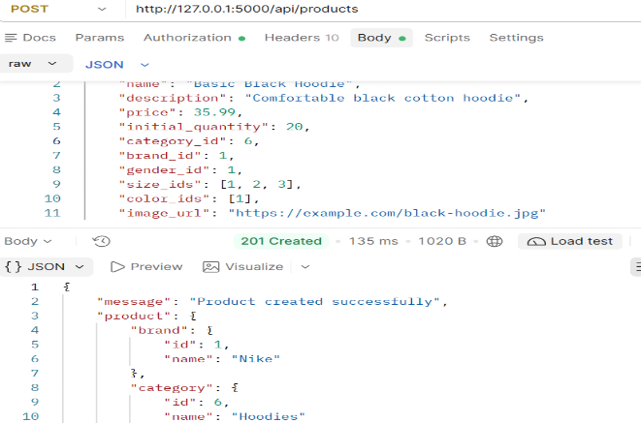
Get one product: GET http://127.0.0.1:5000/api/products/1
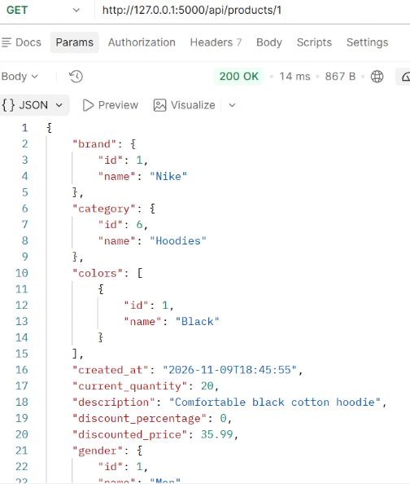
Update a product: PUT http://127.0.0.1:5000/api/products/1
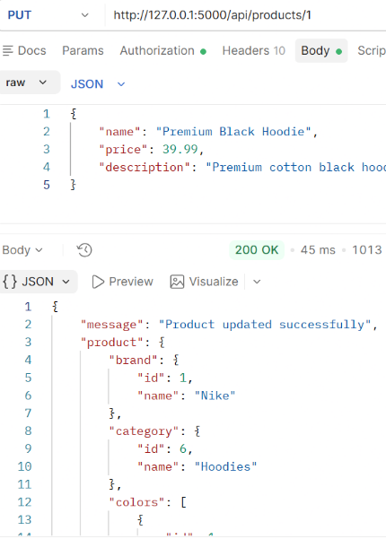
Search product by category_id, gender_id, minimum price and maximum price:
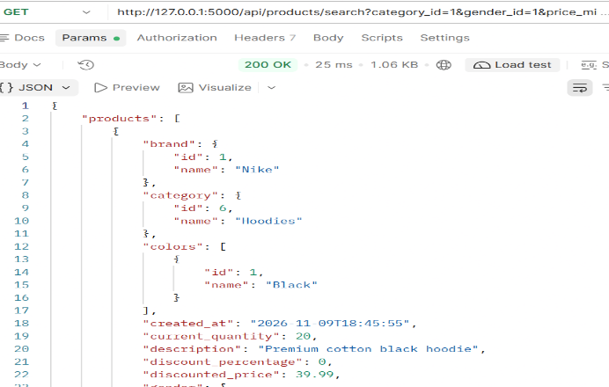
Check product quantity: GET http://127.0.0.1:5000/api/products/1/quantity
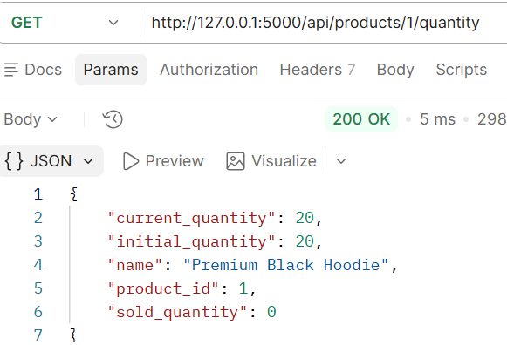
Update stock quantity: PUT http://127.0.0.1:5000/api/products/1/stock
Without forgetting to paste the admin token in Authorization tab
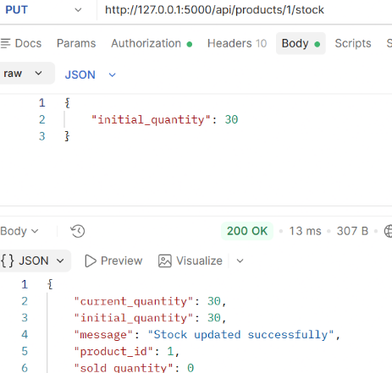
Test product discount, apply 10% discount, paste the admin token
POST http://127.0.0.1:5000/api/products/1/discount
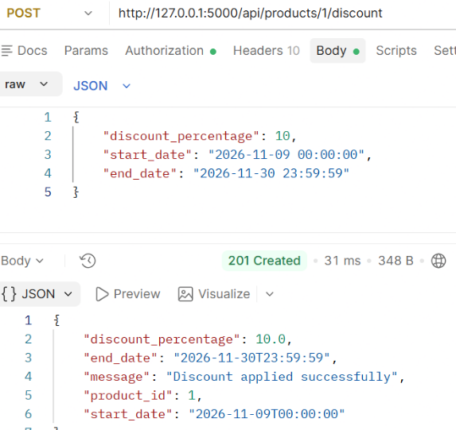
Now check the product with GET http://127.0.0.1:5000/api/products/1
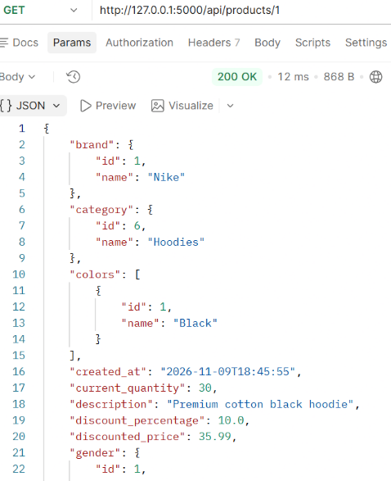 We can see that the discount % is 10%
The original price is 39.99, a 10% discount should produce: 39.99 - (39.99 * 0.10) = 35.991. The API rounds this to 35.99.
Create a customer for ordering: POST http://127.0.0.1:5000/auth/register
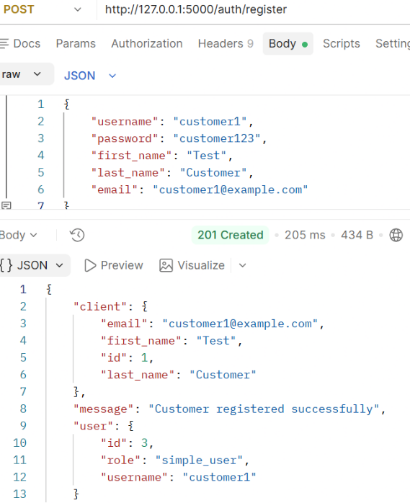
Login as advanced user: POST http://127.0.0.1:5000/auth/login
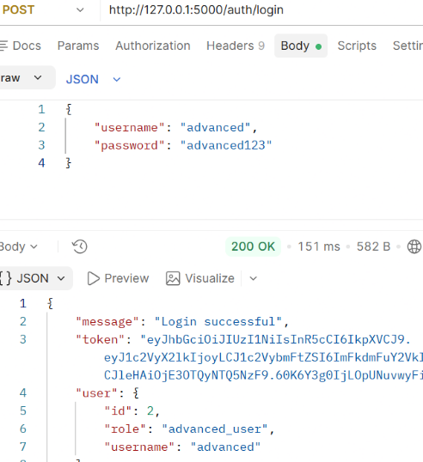
As an advanced user we can create and update users, but can’t delete or apply discount.
We try to delete a product as advanced user and the result:
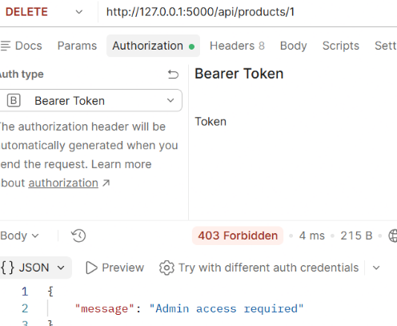
Check daily earning as admin user (it is also visible to advanced users) but not simple users:
GET http://127.0.0.1:5000/api/reports/daily?date=2026-11-09
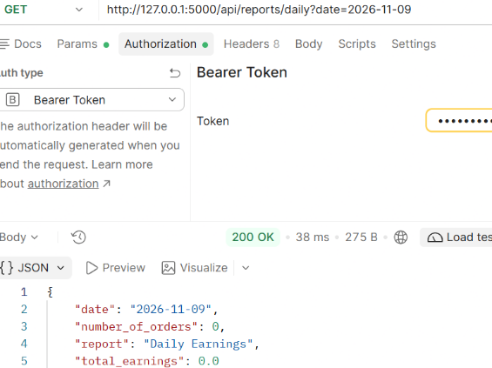
Login as customer: POST http://127.0.0.1:5000/auth/login
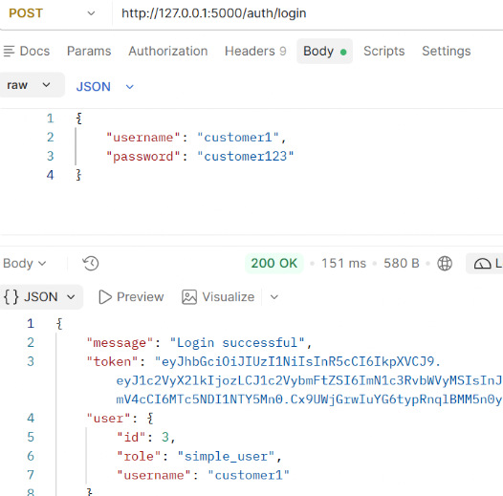
Place an order as customer: POST http://127.0.0.1:5000/api/orders without forgetting to past the customer token in Authorization tab
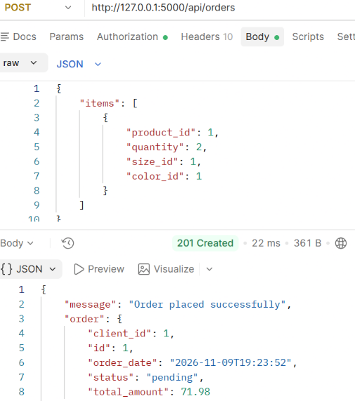
Retrieve customers order: GET http://127.0.0.1:5000/api/orders
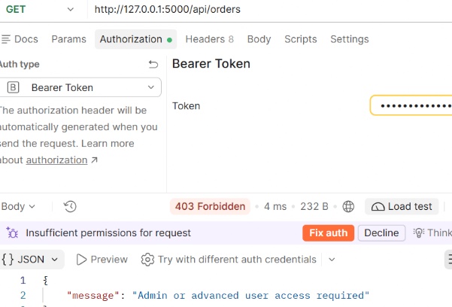 We see that we don’t have access
But the customer can retrieve its order using the ID
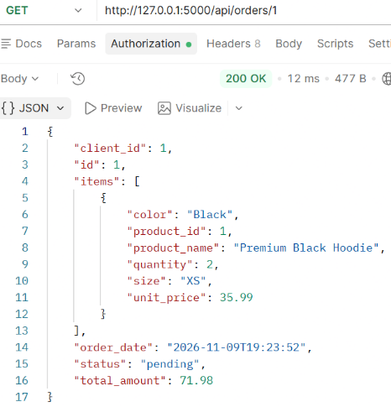
Confirm the order as advanced user PUT http://127.0.0.1:5000/api/orders/1/status
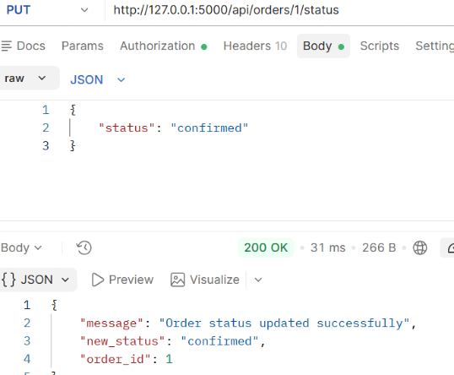
Check product quantity after confirming the order: GET http://127.0.0.1:5000/api/products/1/quantity and see it is decreased
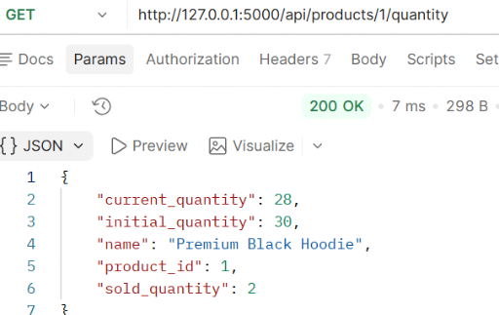
Complete the order as advanced user: PUT http://127.0.0.1:5000/api/orders/1/status
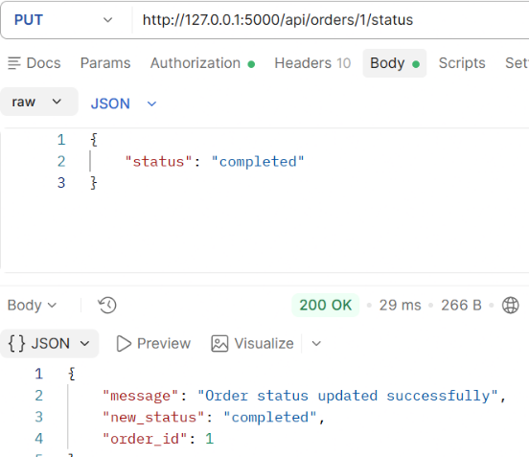
Also let me mention these cases that don’t work:
Advanced user changes completed order to pending = 400 Bad Request
Advanced user changes completed order to cancelled = 400 Bad Request
Customer tries to update order status = 403 Forbidden
Request without a token = 401 Unauthorized
Now let’s see the daily earnings as advanced user
GET http://127.0.0.1:5000/api/reports/daily?date=2026-11-09
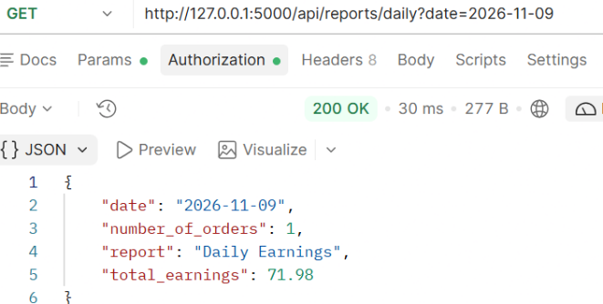
Get top selling products as advanced user: GET http://127.0.0.1:5000/api/reports/top-products?limit=5
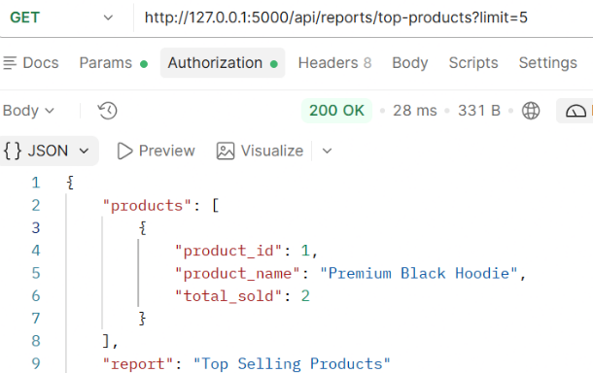
Since the hoodie is the only product I created and placed the order in the reports we can see only this product.

